Use case to identify words in a line/record or a whole file, using your own pipe stage

I want to know the word count in a line/record or a complete file.

Notes:
- The filename will be: WORDS REXX
This way we can use the filename directly as a PIPE stage
- Otherwise you can code | rexx words exec *
- CALLPIPE is used in your own stage to do the “normal” PIPE coding

- Let’s start with some simple code, reading stuff into my own pipe stage
/* Displaying the word count in a line (1st setup) */
Do main=1 /* Starting a loop */
'READTO WORK' /* Take 1 record and put it in variable work */
Say work /* Display... */
End main /* Identifying the end */
Return

Now we issue from the command line: PIPE < PROFILE EXEC A | words |cons
Note: we will use this command during the whole cycle of this use case.

The results are below
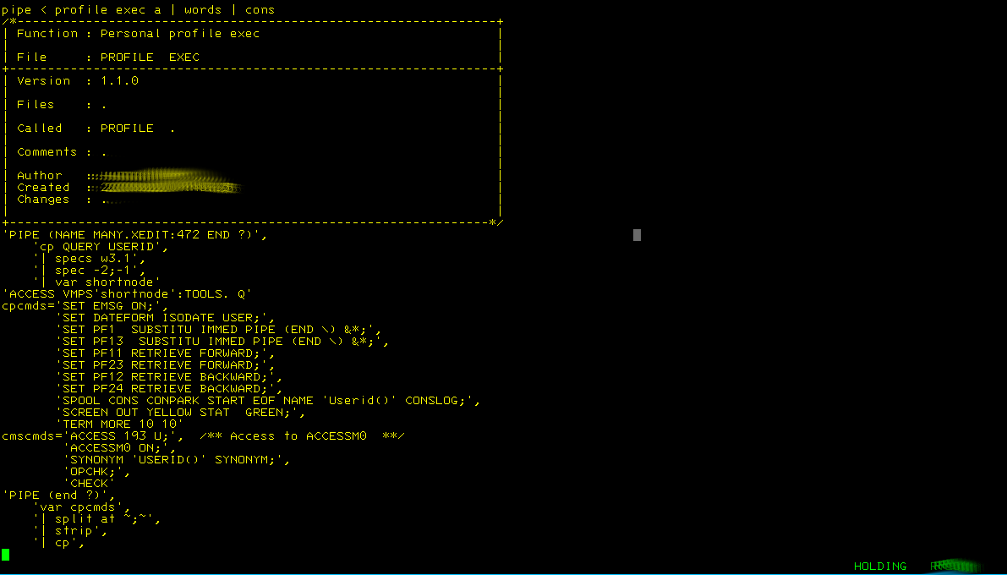
- Oops, we ended up with a loop
/* Displaying the word count in a line (1st setup) */
Do main=1 /* Starting a loop */
'READTO WORK' /* Take 1 record and put it in variable work */
If rc<>0 Then Leave main /* We are at the end of the records */
Say work /* Display... */
End main /* Identifying the end */
Return

Please try it yourself, I will skip the image.

- Now we got that covered we return the output to the caller
/* Displaying the word count in a line (1st setup) */
Do main=1 /* Starting a loop */
'READTO WORK' /* Take 1 record and put it in variable work */
If rc<>0 Then Leave main /* We are at the end of the records */
'CALLPIPE (end ?)', /* Note: we need to use callpipe */
'var work', /* Take the variable */
'| *:' /* ...and feed it into the calling pipe */
End main /* Identifying the end */
Return

You will see the same output as in the first image

- Now we will add the word count
/* Displaying the word count in a line */
Do main=1 /* Starting a loop */
'READTO WORK' /* Take 1 record and put it in variable work */
If rc<>0 Then Leave main /* We are at the end of the records */
'CALLPIPE (end ?)', /* Note: we need to use callpipe */
'var work', /* Take the variable */
'| split', /* ...split it into words */
'| specs recno 1 w1.1 nw', /* Add a record number */
'| *:' /* ...and feed it into the calling pipe */
End main /* Identifying the end */
Return

The results:
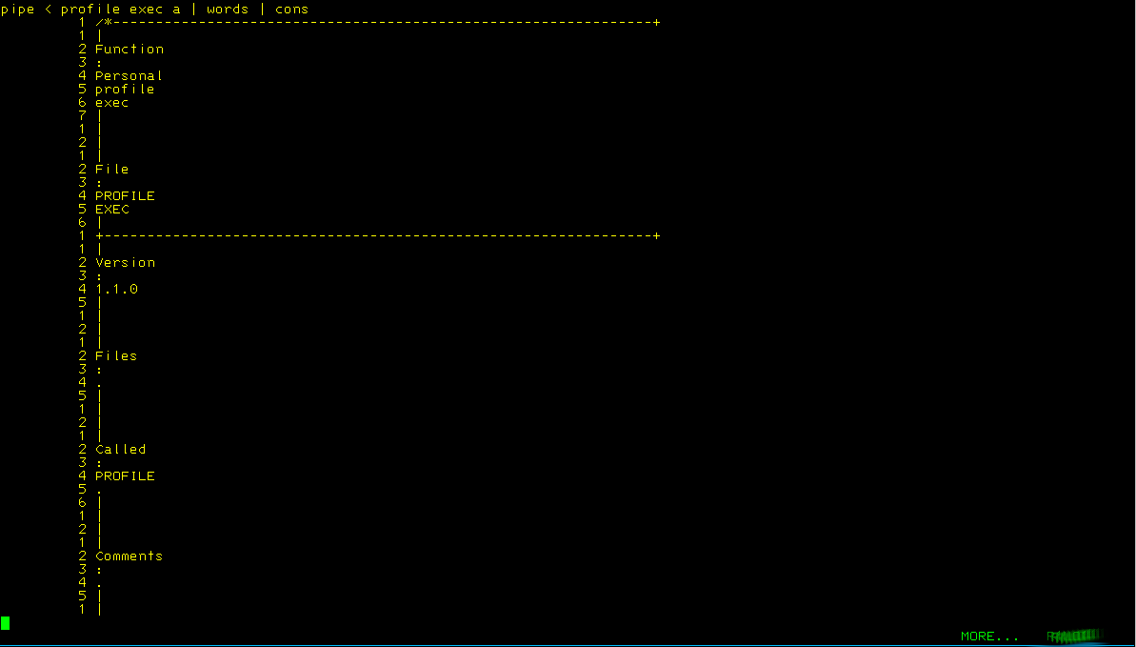
- Now I want to rebuild the record
/* Displaying the word count in a line */
Do main=1 /* Starting a loop */
'READTO WORK' /* Take 1 record and put it in variable work */
If rc<>0 Then Leave main /* We are at the end of the records */
'CALLPIPE (end ?)', /* Note: we need to use callpipe */
'var work', /* Take the variable */
'| split', /* ...split it into words */
'| specs recno 1 w1.1 nw', /* Add a record number */
'| strip', /* Remove spaces */
'| f: fanout', /* Send records to f: */
'| specs w2.1', /* Keep the word */
'| stem word.', /* Store as stem */
'? f:', /* Connect 2 fanout */
'| specs w1.1', /* Keep the count */
'| stem wrdcnt.' /* Store as stem */
wrkline='' /* Initialise this */
Do w=1 To word.0 /* Start a second loop */
wrkline=wrkline wrdcnt.w word.w /* Combine the info */
End w /* Identify the end of the 2nd loop */
'CALLPIPE (end ?)',
'var wrkline', /* Take this var */
'| append var work', /* ...add this */
'| append literal ', /* ....add blank line */
'| *:' /* Send 2 caller */
End main /* Identifying the end */
Return

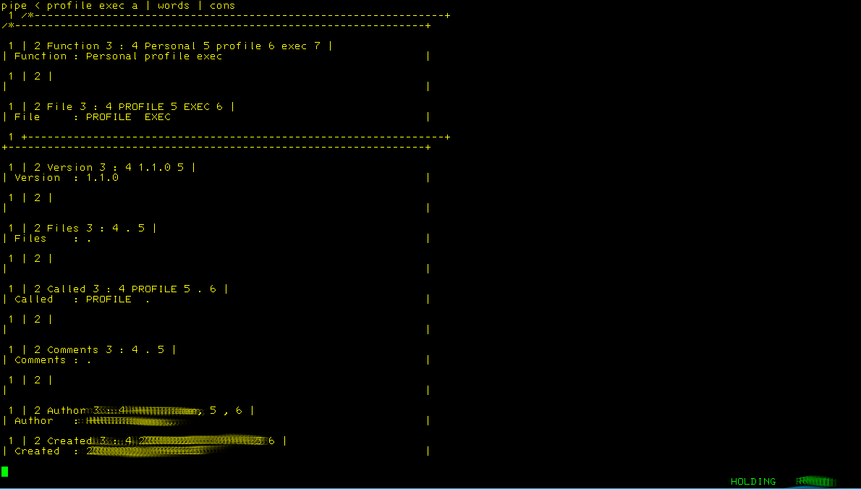
- I do not like the layout that I created, I want the word count and then adjust it to the length of the word with dots (.)
/* Displaying the word count in a line */
Do main=1 /* Starting a loop */
'READTO WORK' /* Take 1 record and put it in variable work */
If rc<>0 Then Leave main /* We are at the end of the records */
'CALLPIPE (end ?)', /* Note: we need to use callpipe */
'var work', /* Take the variable */
'| split', /* ...split it into words */
'| specs recno 1 w1.1 nw', /* Add a record number */
'| strip', /* Remove spaces */
'| f: fanout', /* Send records to f: */
'| specs w2.1', /* Keep the word */
'| stem word.', /* Store as stem */
'? f:', /* Connect 2 fanout */
'| specs w1.1', /* Keep the count */
'| stem wrdcnt.' /* Store as stem */
wrkline='' /* Initialise this */
Do w=1 To word.0 /* Start a second loop */
wrdlen=Length(word.w) /* Get the length of the word */
wrdcnt.w=Left(wrdcnt.w,wrdlen,'.') /* Adjust word count to the length of the word */
wrkline=wrkline wrdcnt.w /* Combine the info */
End w /* Identify the end of the 2nd loop */
'CALLPIPE (end ?)',
'var wrkline', /* Take this var */
'| strip',
'| append var work', /* ...add this */
'| append literal ', /* ....add blank line */
'| *:' /* Send 2 caller */
End main /* Identifying the end */
Return

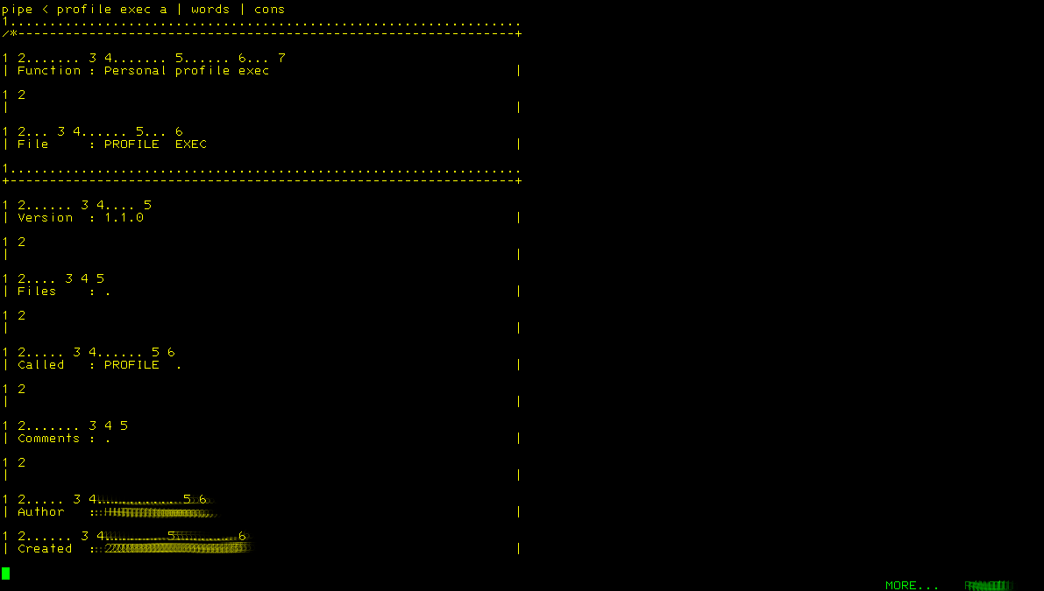
- Still not happy with the results, so some rework needed
/* Displaying the word count in a line */
Do main=1 /* Starting a loop */
'READTO WORK' /* Take 1 record and put it in variable work */
If rc<>0 Then Leave main /* We are at the end of the records */
'CALLPIPE (end ?)', /* Note: we need to use callpipe */
'var work', /* Take the variable */
'| split', /* ...split it into words */
'| specs recno 1 w1.1 nw', /* Add a record number */
'| strip', /* Remove spaces */
'| f: fanout', /* Send records to f: */
'| specs w2.1', /* Keep the word */
'| stem word.', /* Store as stem */
'? f:', /* Connect 2 fanout */
'| specs w1.1', /* Keep the count */
'| stem wrdcnt.' /* Store as stem */
wrkline=work /* Move work into...*/
Do w=1 To word.0 /* Start a second loop */
wrdlen=Length(word.w) /* Get the length of the word */
wrdcnt.w=Left(wrdcnt.w,wrdlen,'.') /* Adjust word count to the lenght of the word */
'CALLPIPE (end ?)',
'var wrkline', /* Take this var */
'| change /'word.w'/'wrdcnt.w'/', /* Change these items */
'| var wrkline' /* Replace variable */
End w /* Identify the end of the 2nd loop */
'CALLPIPE (end ?)',
'var wrkline', /* Take this var */
'| append var work', /* ...add this */
'| append literal ', /* ....add blank line */
'| *:' /* Send 2 caller */
End main /* Identifying the end */
Return

The results:
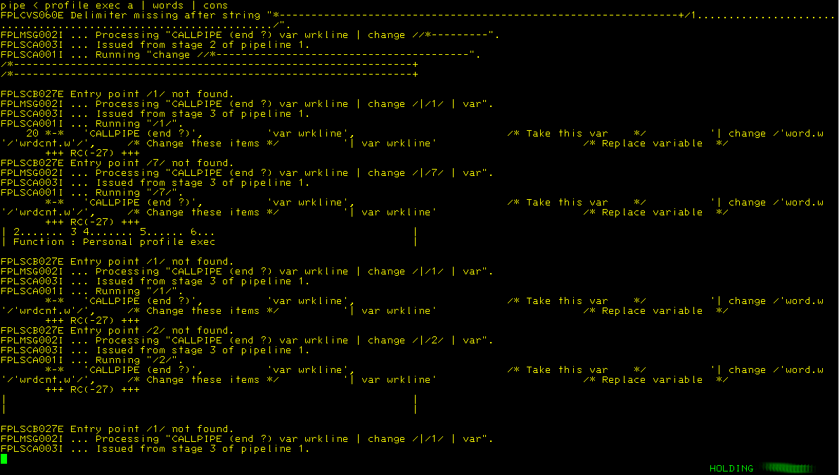
- Not really what we want...some drastic action needed
/* Displaying the word count in a line */
dlm_char='00'x /* Delimiter character */
Do main=1 /* Starting a loop */
'READTO WORK' /* Take 1 record and put it in variable work */
If rc<>0 Then Leave main /* We are at the end of the records */
'CALLPIPE (end ?)', /* Note: we need to use callpipe */
'var work', /* Take the variable */
'| split', /* ...split it into words */
'| specs recno 1 w1.1 nw', /* Add a record number */
'| strip', /* Remove spaces */
'| f: fanout', /* Send records to f: */
'| specs w2.1', /* Keep the word */
'| stem word.', /* Store as stem */
'? f:', /* Connect 2 fanout */
'| specs w1.1', /* Keep the count */
'| stem wrdcnt.' /* Store as stem */
wrkline=work /* Move work into...*/
Do w=1 To word.0 /* Start a second loop */
wrdlen=Length(word.w) /* Get the length of the word */
wrdcnt.w=Left(wrdcnt.w,wrdlen,'.') /* Adjust word count to the lenght of the word */
'CALLPIPE (end ?)',
'var wrkline', /* Take this var */
'| change 'dlm_char||word.w||dlm_char||wrdcnt.w||dlm_char, /* Change these items */
'| var wrkline' /* Replace variable */
End w /* Identify the end of the 2nd loop */
'CALLPIPE (end ?)',
'var wrkline', /* Take this var */
'| append var work', /* ...add this */
'| append literal ', /* ....add blank line */
'| *:' /* Send 2 caller */
End main /* Identifying the end */
Return

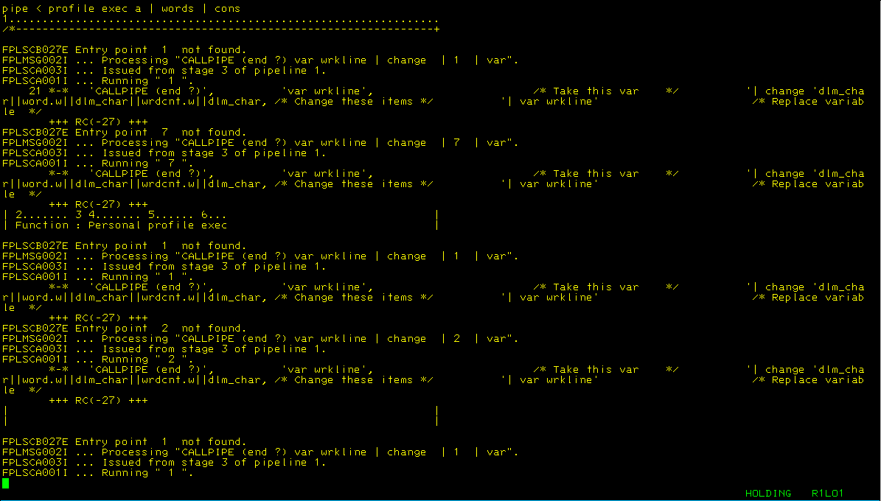
- Still not what we want...
/* Displaying the word count in a line */
dlm_char='00'x /* Delimiter character */
stg_char='01'x /* Stage separator character */
Do main=1 /* Starting a loop */
'READTO WORK' /* Take 1 record and put it in variable work */
If rc<>0 Then Leave main /* We are at the end of the records */
'CALLPIPE (end ?)', /* Note: we need to use callpipe */
'var work', /* Take the variable */
stg_char' split', /* ...split it into words */
stg_char' specs recno 1 w1.1 nw', /* Add a record number */
stg_char' strip', /* Remove spaces */
stg_char' f: fanout', /* Send records to f: */
stg_char' specs w2.1', /* Keep the word */
stg_char' stem word.', /* Store as stem */
'? f:', /* Connect 2 fanout */
stg_char' specs w1.1', /* Keep the count */
stg_char' stem wrdcnt.' /* Store as stem */
wrkline=work /* Move work into...*/
Do w=1 To word.0 /* Start a second loop */
wrdlen=Length(word.w) /* Get the length of the word */
wrdcnt.w=Left(wrdcnt.w,wrdlen,'.') /* Adjust word count to the lenght of the word */
'CALLPIPE (end ?)',
'var wrkline', /* Take this var */
stg_char' change 'dlm_char||word.w||dlm_char||wrdcnt.w||dlm_char, /* Change items */
stg_char' var wrkline' /* Replace variable */
End w /* Identify the end of the 2nd loop */
'CALLPIPE (end ?)',
'var wrkline', /* Take this var */
stg_char' append var work', /* ...add this */
stg_char' append literal ', /* ....add blank line */
stg_char' *:' /* Send 2 caller */
End main /* Identifying the end */
Return

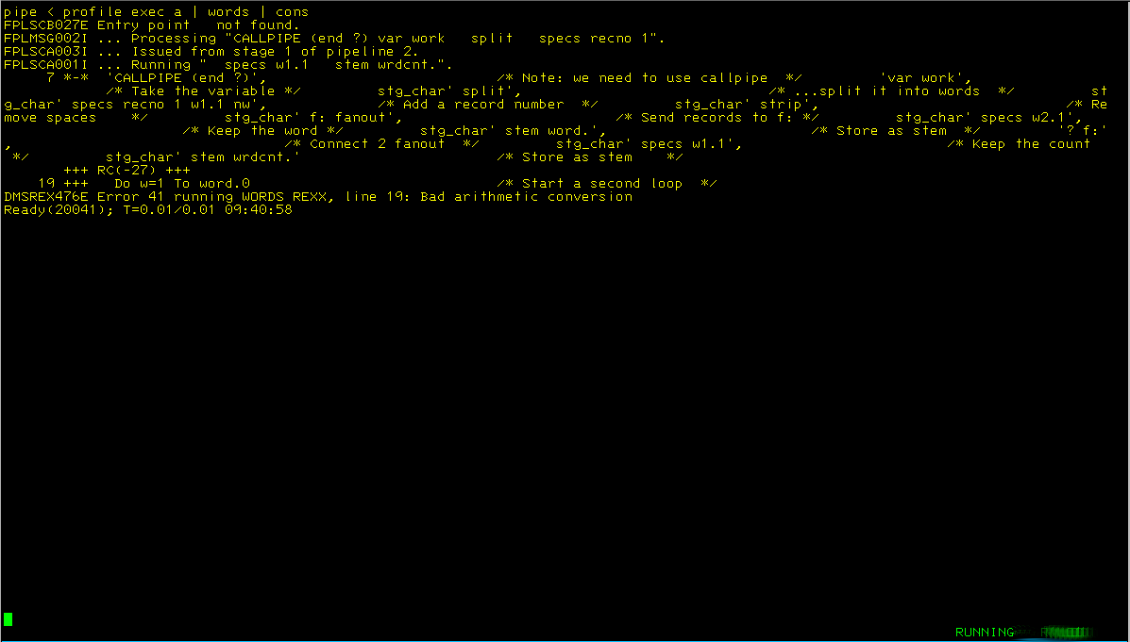
- Ok, not a big improvement...time for more changes
/* Displaying the word count in a line */
dlm_char='00'x /* Delimiter character */
stg_char='01'x /* Stage separator character */
end_char='FF'x /* End character */
Do main=1 /* Starting a loop */
'READTO WORK' /* Take 1 record and put it in variable work */
If rc<>0 Then Leave main /* We are at the end of the records */
'CALLPIPE (end 'end_char')', /* Note: we need to use callpipe */
'var work', /* Take the variable */
stg_char' split', /* ...split it into words */
stg_char' specs recno 1 w1.1 nw', /* Add a record number */
stg_char' strip', /* Remove spaces */
stg_char' f: fanout', /* Send records to f: */
stg_char' specs w2.1', /* Keep the word */
stg_char' stem word.', /* Store as stem */
end_char' f:', /* Connect 2 fanout */
stg_char' specs w1.1', /* Keep the count */
stg_char' stem wrdcnt.' /* Store as stem */
wrkline=work /* Move work into...*/
Do w=1 To word.0 /* Start a second loop */
wrdlen=Length(word.w) /* Get the length of the word */
wrdcnt.w=Left(wrdcnt.w,wrdlen,'.') /* Adjust word count to the lenght of the word */
'CALLPIPE (end 'end_char')',
'var wrkline', /* Take this var */
stg_char' change 'dlm_char||word.w||dlm_char||wrdcnt.w||dlm_char, /* Change these items */
stg_char' var wrkline' /* Replace variable */
End w /* Identify the end of the 2nd loop */
'CALLPIPE (end 'end_char')',
'var wrkline', /* Take this var */
stg_char' append var work', /* ...add this */
stg_char' append literal ', /* ....add blank line */
stg_char' *:' /* Send 2 caller */
End main /* Identifying the end */
Return

- Some more fiddling to get the correct output:
/* Displaying the word count in a line */
dlm_char='FF'x /* Delimiter character */
stg_char='00'x /* Stage separator character */
end_char='01'x /* End character */
Do main=1 /* Starting a loop */
'READTO WORK' /* Take 1 record and put it in variable work */
If rc<>0 Then Leave main /* We are at the end of the records */
'CALLPIPE (stagesep 'stg_char' end 'end_char')', /* Note: we need to use callpipe */
'var work', /* Take the variable */
stg_char' split', /* ...split it into words */
stg_char' stem wrd.', /* Store as stem */
stg_char' specs recno 1', /* Add a record number */
stg_char' strip', /* Remove spaces */
stg_char' stem wrdcnt.' /* Store as stem */
wrkline=work /* Move work into...*/
Do w=1 To wrd.0 /* Start a second loop */
wrdlen=Length(wrd.w) /* Get the length of the word */
wrdcnt.w=Left(wrdcnt.w,wrdlen,'.') /* Adjust word count to the lenght of the word */
'CALLPIPE (stagesep 'stg_char' end 'end_char')',
'var wrkline', /* Take this var */
stg_char' change 'dlm_char||wrd.w||dlm_char||wrdcnt.w||dlm_char, /* Change these items */
stg_char' var wrkline' /* Replace variable */
End w /* Identify the end of the 2nd loop */
'CALLPIPE (stagesep 'stg_char' end 'end_char')',
'var wrkline', /* Take this var */
stg_char' append var work', /* ...add this */
stg_char' append literal ', /* ....add blank line */
stg_char' *:' /* Send 2 caller */
End main /* Identifying the end */
Return

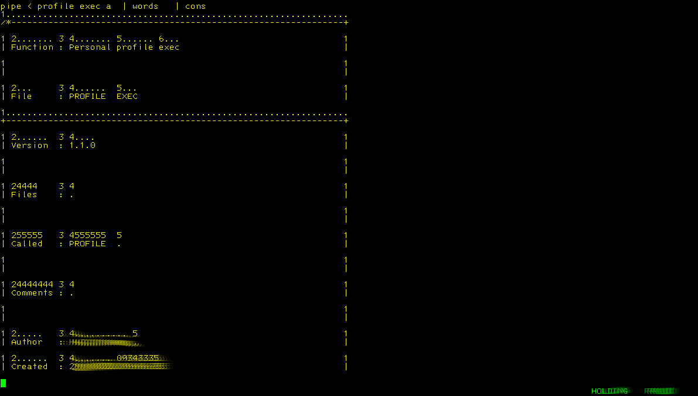
- Oops some thing wrong in the second to last line...
* * * Top of File * * *
/* Displaying the word count in a line */
dlm_char='FF'x /* Delimiter character */
stg_char='00'x /* Stage separator character */
end_char='01'x /* End character */
Do main=1 /* Starting a loop */
'READTO WORK' /* Take 1 record and put it in variable work */
If rc<>0 Then Leave main /* We are at the end of the records */
'CALLPIPE (stagesep 'stg_char' end 'end_char')', /* Note: we need to use callpipe */
'var work', /* Take the variable */
stg_char' split', /* ...split it into words */
stg_char' stem wrd.', /* Store as stem */
stg_char' specs recno 1', /* Add a record number */
stg_char' strip', /* Remove spaces */
stg_char' stem wrdcnt.' /* Store as stem */
wrkline=work /* Move work into...*/
Do w=1 To wrd.0 /* Start a second loop */
wrdlen=Length(wrd.w) /* Get the length of the word */
wrdcnt.w=Left(wrdcnt.w,wrdlen,'.') /* Adjust word count to the lenght of the word */
'CALLPIPE (stagesep 'stg_char' end 'end_char')',
'var wrkline', /* Take this var */
stg_char' change 'dlm_char||, /* Make it */
wrd.w||, /* ..easier */
dlm_char||, /* ...to */
wrdcnt.w||, /* .....read */
dlm_char' 1', /* Change these items */
stg_char' var wrkline' /* Replace variable */
End w /* Identify the end of the 2nd loop */
'CALLPIPE (stagesep 'stg_char' end 'end_char')',
'var wrkline', /* Take this var */
stg_char' append var work', /* ...add this */
stg_char' append literal ', /* ....add blank line */
stg_char' *:' /* Send 2 caller */
End main /* Identifying the end */
Return

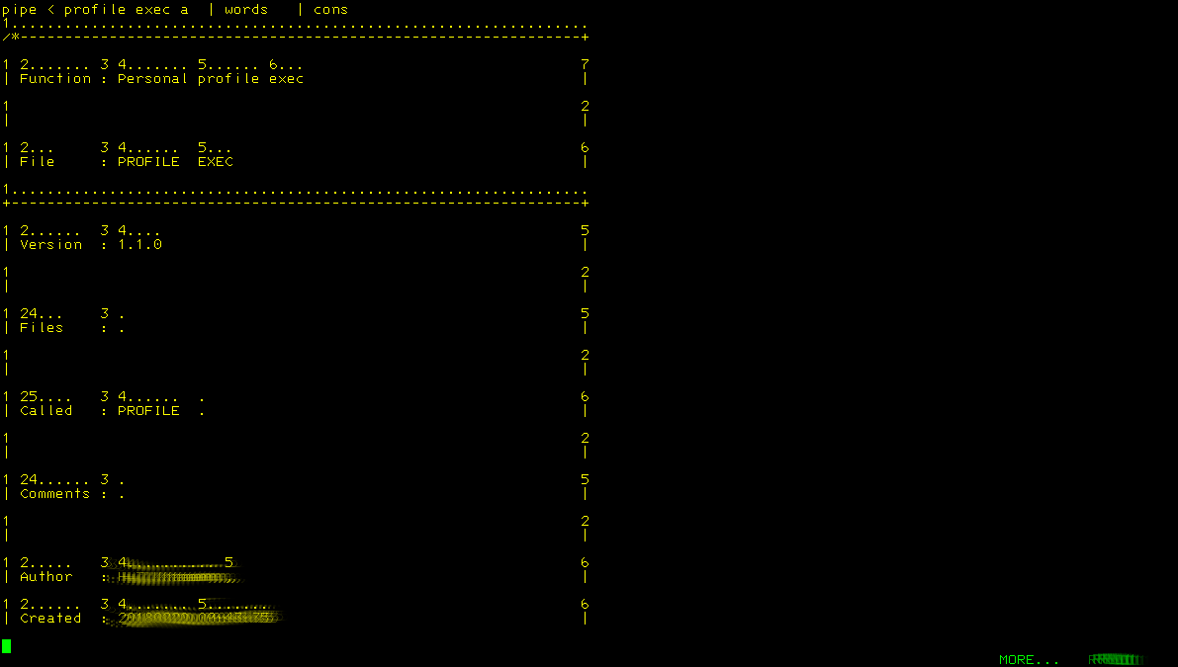
- Now adding some comments and smarten the content:
/*---------------------------------------------------------------+
| Function : Show the word count of a line and then the |
| actual content |
| |
| File : WORDS REXX |
+----------------------------------------------------------------+
| Version : 1.1.0 |
| |
| Files : . |
| |
| Called : WORDS . |
| |
| Comments : . |
| |
| Author : H.T.Kramer, , |
| Created : 20200806 13:45:50 |
| Changes : . |
| |
+---------------------------------------------------------------*/
/*---------------------------------------------------------------+
| Initialise some variables |
+---------------------------------------------------------------*/
dlm_char='FF'x /* Delimiter character */
stg_char='00'x /* Stage separator character */
end_char='01'x /* End character */
/*---------------------------------------------------------------+
| Starting the main loop |
+---------------------------------------------------------------*/
Do main=1 /* Starting a loop */
'READTO WORK' /* Take 1 record and put it in variable work */
If rc<>0 Then Leave main /* We are at the end of the records */
'CALLPIPE (stagesep 'stg_char' end 'end_char')', /* Note: we need to use callpipe */
'var work', /* Take the variable */
stg_char' split', /* ...split it into words */
stg_char' stem wrd.', /* Store as stem */
stg_char' specs recno 1', /* Add a record number */
stg_char' strip', /* Remove spaces */
stg_char' stem wrdcnt.' /* Store as stem */
wrkline=work /* Move work into...*/
/*---------------------------------------------------------------+
| We loop thru the words and counters |
+---------------------------------------------------------------*/
Do w=1 To wrd.0 /* Start a second loop */
wrdlen=Length(wrd.w) /* Get the length of the word */
wrdcnt.w=Left(wrdcnt.w,wrdlen,'.') /* Adjust word count to the lenght of the word */
'CALLPIPE (stagesep 'stg_char' end 'end_char')',
'var wrkline', /* Take this var */
stg_char' change 'dlm_char||, /* Make it */
wrd.w||, /* ..easier */
dlm_char||, /* ...to */
wrdcnt.w||, /* .....read */
dlm_char' 1', /* Change these items */
stg_char' var wrkline' /* Replace variable */
End w /* Identify the end of the 2nd loop */
/*---------------------------------------------------------------+
| Here we hand the records to the caller... |
+---------------------------------------------------------------*/
'CALLPIPE (stagesep 'stg_char' end 'end_char')',
'var wrkline', /* Take this var */
stg_char' append var work', /* ...add this */
stg_char' append literal ', /* ....add blank line */
stg_char' *:' /* Send 2 caller */
End main /* Identifying the end */
Return

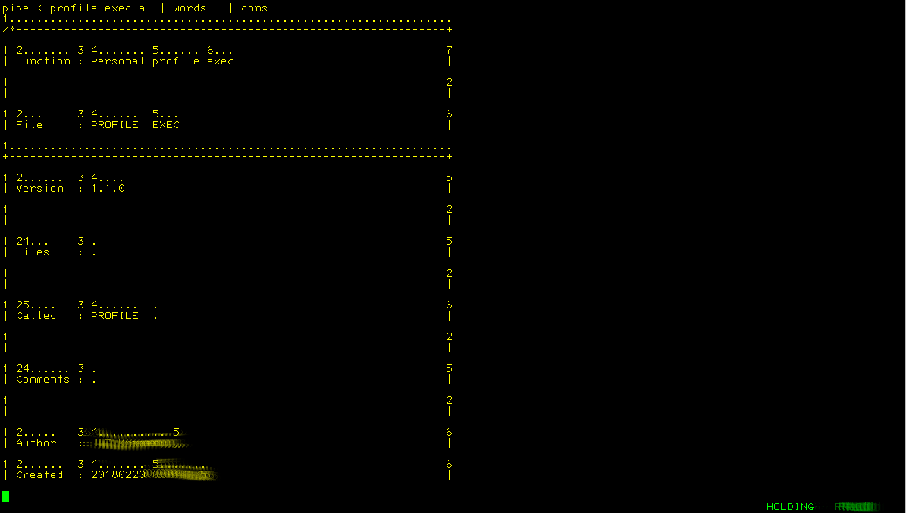

- Below a version without the ‘READTO’
/*---------------------------------------------------------------+
| Function : Show the word count of a line and then the |
| actual content |
| |
| File : WORDS REXX |
+----------------------------------------------------------------+
| Version : 2.1.0 |
| |
| Files : . |
| |
| Called : WORDS . |
| |
| Comments : Note: this is for display only |
| |
| Author : H.T.Kramer, , |
| Created : 20200806 13:45:50 |
| Changes : . |
| 20200806 H.T.Kramer : Replaces READTO with |
| CALLPIPE *: |
| |
+---------------------------------------------------------------*/
/*---------------------------------------------------------------+
| Initialise some variables |
+---------------------------------------------------------------*/
dlm_char='FF'x /* Delimiter character */
stg_char='00'x /* Stage separator character */
end_char='01'x /* End character */
out.0=0 /* Initialise a stem */
/*---------------------------------------------------------------+
| Receive all records from the calling pipe |
+---------------------------------------------------------------*/
'CALLPIPE (stagesep 'stg_char' end 'end_char')',
' *:', /* Take all records from the calling pipe */
stg_char' stem record.' /* Store them as an array */
/*---------------------------------------------------------------+
| Starting the main loop |
+---------------------------------------------------------------*/
Do l=1 To record.0 /* Starting a loop */
work=record.l /* Move 1 record into work */
'CALLPIPE (stagesep 'stg_char' end 'end_char')',
'var work', /* Take the variable */
stg_char' split', /* ...split it into words */
stg_char' stem wrd.', /* Store as stem */
stg_char' specs recno 1', /* Add a record number */
stg_char' strip', /* Remove spaces */
stg_char' stem wrdcnt.' /* Store as stem */
wrkline=work /* Move work into...*/
/*---------------------------------------------------------------+
| We loop thru the words and counters |
+---------------------------------------------------------------*/
Do w=1 To wrd.0 /* Start a second loop */
wrdlen=Length(wrd.w) /* Get the length of the word */
wrdcnt.w=Left(wrdcnt.w,wrdlen,'.') /* Adjust word count to the lenght of the word */
'CALLPIPE (stagesep 'stg_char' end 'end_char')',
'var wrkline', /* Take this var */
stg_char' change 'dlm_char||, /* Make it */
wrd.w||, /* ..easier */
dlm_char||, /* ...to */
wrdcnt.w||, /* .....read */
dlm_char' 1', /* Change these items */
stg_char' var wrkline' /* Replace variable */
End w /* Identify the end of the 2nd loop */
/*---------------------------------------------------------------+
| Here we hand the records to the caller... |
+---------------------------------------------------------------*/
'CALLPIPE (stagesep 'stg_char' end 'end_char')',
'var wrkline', /* Take this var */
stg_char' append var work', /* ...add this */
stg_char' append literal ', /* ....add blank line */
stg_char' stem out. append' /* Append it to a stem */
End l /* Identifying the end */
'CALLPIPE (stagesep 'stg_char' end 'end_char')',
'stem out.', /* Take this array */
stg_char' *:' /* Feed them into the calling pipe */
Return

